Sample Concentrator(Water Bath)—WD1000
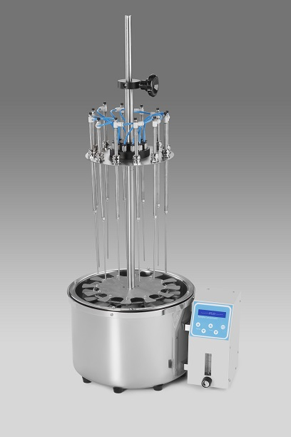
- Introduction
The Water Bath Sample Concentration consists of a base and supporting assembly, sample holder and gas distribution system. Test tubes are placed by a spring-loaded sample holder and support tray. The gas passes through the flow meter to the distribution system. Flexible tubing leads gas to valve-tube assemblies at each position. Depending on the test-tube size and solvent volume, they can be individually raised or lowered to the correct height. Needles blow gas onto the surface of the solution resulting in rapid evaporation of the solvent.

Features:
- LCD display, easy operation; safe and reliable to use.
- Water bath provides gentle heat.
- Accommodates sample in tubes(diameter 10~29mm), volume(1~ 50ml).
- 12positions, each position is numbered.
- Blowing each sample independently.
- With liquid-level sensor, have alarming function when dry heating.
- The lifting needle valve controls the gas consumption at each position.
- All parts are anti-corrosion, durable in use, easy to clean.
Main application fields:
- Analysis of pesticide residues: vegetables, fruits, cereals, plant tissue.
- Environmental analysis: drinking water, groundwater and polluted water.
- Biological analysis: such as hormone analysis, sample preparation of liquid phase and gas phase and mass spectrometry analysis.
- Food and beverage: such as milk, wine, beer, etc.
- Pharmaceutical drug testing: such as traditional Chinese medicine pharmaceutical, drug screening.

- Normal Operating Condition
Ambient temp：0°C ∼ 35°C
Relative humidity ：≤70%
Power supply：AC220V~5A 50-60Hz

- Parameters and performance
Model | WD1000
Temp. range | RT.+5℃~99℃
Time range | 1min~99h59min/∞
Display accuracy | ±0.1℃
Temp accuracy | ≤±1℃
Temp uniformity (@60℃) | ≤±1℃
Heating time（40℃-99℃） | ≤30min
Samples position | 12positions
Tube size | φ10~φ29(liquid volume 1ml~50ml)
Max vertical travel | 200mm
Max gas pressure | 200Kpa
Max gas usage | 15L/min
Gas joint diameter | φ8
Power | 1000W
Fuse | 250V 8A φ5×20
Dimension(mm) | 390×300×850
Weight(kg) | 10

